[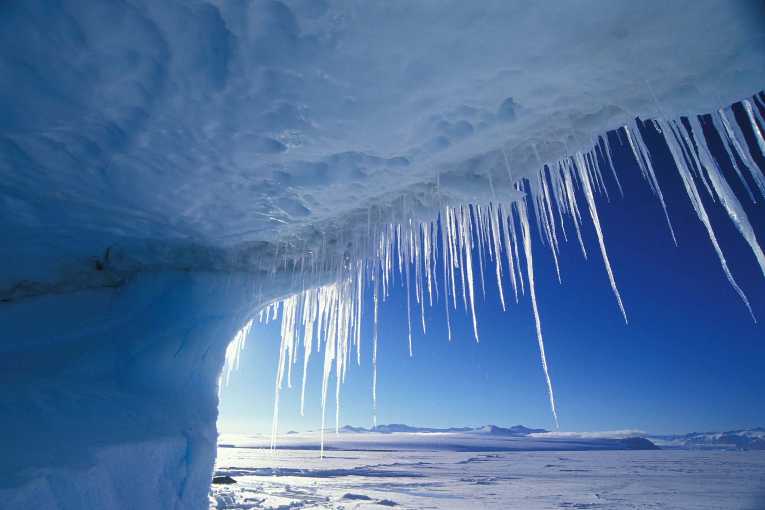](http://www.37southyachtcharter.com/destinations/polar-regions/antarctica/)

Shackleton Exploration Journey through the Antarctic

Possible FAME! And FORTUNE!

**Sick of going to sunny places. Well come with us to the wonderland of clear white snow! It will be an exciting adventure with laughter.**

**Amrit deogun 26 Burlington St.**

**MEN WANTED!!!**